A Brief History of Elmore

Introduction
Elmore is a small country town in Victoria, Australia, 45 kilometres north - east of Bendigo, and 178 kilometres north of Melbourne, on the Campaspe River. In 2016, Elmore had a population of 776 people, is part of the City of Greater Bendigo, which is an Australian local government area, located in the central part of Victoria, and Elmore is still home to many localised farming industries. Elmore gets its name from another town in Gloucestershire, England.
First Nations People
The Dja Dja Wurrung people lived along the Campaspe River, in Elmore, 10s of thousands of years ago. It’s likely the Dja Dja Wurrung people relied on the Campaspe River, which runs through Elmore, from Wombat State Forest and then flows into the Murray River, for essential everyday activities. These activities might have included: fishing for food, accessing drinking water when the river was clean, due to no pollution, washing, and cultural ceremonies. In the 1840s, european settlers came to Elmore, cleared land for farming and laid claim to the Dja Dja Wurrung land.

Campaspe River
The Campaspe River rises in the Macedon Ranges and enters the Murray River, in Echuca. Lake Eppalock, constructed in the 1960s, is situated on the Campaspe River. The Campaspe River Walking Track, from Childers street, Elmore, back to the Campaspe Bridge was originally constructed by the former Shire of Huntly, to celebrate their 125th anniversary. Included in the development was a playground which was removed. Although, recently, The EPA, (Elmore Progress Association), alongside The City of Greater Bendigo, in 2014, made a natural playspace, with a sandpit, on the original playground site. Along the track, there are information boards that inform you of the unique attributes from this stretch of the river. Today, the walking track stretches from Campaspe Bridge (corner of Margaret and Jeffrey streets) to the corner of Campaspe and Childers streets.

Shire of Huntly
The Shire of Huntly was a local government area immediately to the north east of the regional city Bendigo. The shire covered an area of 878 square kilometres, 339 square miles, and existed from 1861 until 1994. The town of Huntly is around 10 kilometers north of the centre of Bendigo. The need for a council at Huntly arose from gold and quartz mining in the area, including alluvial deposits and some deep leads in the area. Huntly was first incorporated as a road district on the 10th of March, 1861, and became a shire on the 13th of July, 1866. From 1867 until 1977, councillors met at the Council Chambers in Huntly, but subsequently moved to another location. On the 7th of April, 1994, the Shire of Huntly was abolished, and, along with the City of Bendigo, the Borough of Eaglehawk, the Rural City of Marong, and the Shire of Strathfieldsaye, was merged into the newly created City of Greater Bendigo. The locations that were in the Shire of Huntly, included Ascot, Avonmore, Bagshot, Barnadown, Diggora, Drummartin, Elmore, Epsom, Fosterville, Goornong, Hunter, Huntly, Kamarooka, May Reef, Minto and Warragamba. The shire’s south west corner adjoined Epsom, its eastern border was the Campaspe River and its northern border ran through Diggora West. In 1994, farming took up 73% of the shire’s area, on which 7,300 cattle, 83,000 pigs and 106,000 sheep and lambs were raised. Nearly 13,000 tonnes of wheat were grown. The Council Chambers for the Shire of Huntly were designed by a local engineer, John O’Dwyer.

Sunshine Harvester Works
In 1884, Hugh Victor McKay, most commonly known as H.V McKay invented the Sunshine Harvester, which could harvest, thresh and winnow wheat. Unlike others of that time, he was able to successfully market his machine. McKay developed and expanded the manufacture of a lot of farm machinery and products. In 1904, McKay heard a sermon on Sunshine, the power of sunshine, the benefits of sunshine. He was impressed by the sermon and decided to call his machine the Sunshine Harvester. Sunshine, a suburb in Melbourne’s industrial west, was home to the major agricultural implements factory, the Sunshine Harvester Works, for 80 years. In 1906, H.V McKay, relocated his Sunshine Harvester Works from Ballarat to Braybrook Junction, a small village outside Melbourne. By 1907, McKay’s Harvester Works had come to dominate the area. Braybrook Junction was renamed Sunshine, after the factory. As well as building a successful factory, McKay established a housing estate at Sunshine. Here his employees could buy houses and enjoy community facilities, such as, gardens, tennis courts and a church. The streets were lined with trees and electricity was supplied to the housing estate from the factory. Sadly, McKay died at the age of 60, in 1926, and in his will he provided for the establishment of the H.V McKay Charitable Trust, which still operates today. And sure enough, in 1954, McKay’s 3 surviving children set up the Sunshine Foundation by endowing it with a large capital gift which has allowed grants to be made to support or encourage charitable ventures. Along Railway Place, in Elmore, there is a H.V McKay Rural Discovery Centre, which provides information about the Sunshine Harvester and other farming machinery.

Elmore Oil
Ralph Linford grew up in Elmore during the great depression. As Ralph grew older he found that he was getting arthritis in his hands. In 1998, Ralph combined his love of nature and his background in chemistry and developed a product using four natural ingredients: eucalypt, tea tree, vanilla extract and olive oil. Ralph knew that 2 of those ingredients, eucalyptus oil and tea tree oil, had been used for pain relief for thousands of years. Elmore Oil gives temporary pain relief and is an anti - inflammatory, that may assist with joint mobility. Today, Elmore Oil is shipped to 14 countries around the world, from the US to the UK and China.

Elmore Railway Station and Water Tower
In 1870, P. Cunningham constructed the Runnymede Railway Station and Water Tower, for the Victorian Railways, but six years later, in 1876, it was renamed the Elmore Railway Station and Water Tower. It is a railway station on the Deniliquin Railway Line, which runs from the border settlement of Deniliquin into Bendigo, before turning south - southeast towards Melbourne, terminating in Docklands near the central business district. There was a short branch line to Cohuna, but it was closed in 1891, and the connection was removed in July 1988. There are five old stations that are no longer used anymore between Elmore and Bendigo. They are Avonmore, Goornong, Wellsford, Bagshot and Huntly. The Elmore Railway Station Water Tower was constructed from locally made bricks. Water was pumped from the Campaspe River to the water tower to supply water for steam trains. The building was donated to the EPA, in 1972 and is the current headquarters for the EPA. In 1954, Queen Elizabeth II travelled, by train, through Elmore!

Parson’s Store
The Parson’s Store was originally called the Wearings Cosmopolitan Store and first opened in 1875. In 1893, it was owned by Thomas Parsons, who added several extensions to the building. Available to purchase were groceries, draperies, furniture, ironmongery, crockery, stationery and fancy goods. Today, the Parson’s Store is used as a display cabinet and storage workroom for the Elmore Miniature Railway.

Elmore Athenaeum Hall
The Elmore Athenaeum Hall was built in 1885 for $1,455 and opened in 1886. The Athenaeum Hall was designed by W.C Vahland and built by Mr G. Galbraith. It served as a hall for public entertainment, church services for the Church of England and Presbyterian , Library, Library Club Rooms, Billiard Room with four tables from 1924 - 1965 and it was used as the Scout Hall Room from 1970 - 1980. As the building became unused and vacant in 1982, it was vandalised and under threat of demolition, so a small group of 9 members was formed and called ‘ Save The Athenaeum Hall Committee’, to restore the hall to its former glory. It was reopened in 2002 and is now the Elmore Library.

Elmore Memorial Hall
The Elmore Hall Complex began on this site in 1866 with the first government school, The Elmore Common School, which is now the kitchen of the complex. It was closed in 1875, when The Mechanics Institute of Victoria took over. In 1920, it was proposed to build a Memorial to the local service men of WWI and to provide work for some of the returned men. The design of the hall is very unique, built of reinforced concrete. Inside, a movie projector box was built in the front, in a second storey. This was thinking forward, as movies were, at the time, very new. The hall was used as a picture theatre, until the new invention, the television. The projector box is still intact. Today, the hall is used for community functions, dances, balls and school and theatre groups. When the restoration of the Athenaeum Hall was happening, it was voted that they should join the buildings together by a glass vestibule from the Athenaeum Hall to the kitchen.

Elmore Recreation Reserve and Football Netball Club
The Elmore Recreation Reserve, managed by the Elmore Recreation Reserve Committee, include, the Caravan Park, golf course, trotting track and bowling greens all built in 1924, skate park, netball courts, built in 1962, tennis courts, built in 1964, skate park, built in 2003, and football oval and club rooms, not recorded but the club started before 1900. The Elmore Football Netball Club competes in the HDFL (Heathcote and District Football League). They are known as the Elmore Bloods because of their colours, red an white. The Football Club started before the 1900s, but they have only played footy in the HDFL since 1948. The Runnymede Junior Football Club are based around Elmore, Colbinabbin and Goornong and they play in Elmore as well. They currently have an under 12s team.

Elmore Field Days and Summer Send off BNS
The Elmore Events Centre is a unique facility, ideal for hosting a wide variety of events that include exhibitions, equestrian competitions, food festivals, vehicle rallies, markets, industry and trade exhibitions, product launches and demonstrations and club and country events. The site offers 154 hectares of versatile outdoor space and even an airstrip. The Elmore Events Centre also hosts the Elmore Field Days and the Elmore Summer Send off BNS. The Elmore Field Days was founded in 1964 by George Holmberg and his Elmore Field Days Official Party. The Field Days is a yearly 3 day event held at the Elmore Events Centre. The Elmore Field Days offers the opportunity to be involved in an agricultural event that is beneficial to trade and highlights information, education and demonstration of the latest agricultural technology, research and equipment. This 3 day event usually attracts a large crowd of around thirty thousand people. The Field Days also has markets selling various things or foods, plus they also have farming machinery on display. All the profit goes back to the community for their volunteering or as donations to fund community services or activities. The Elmore Summer Send off BNS is a yearly Bachelors and Spinsters ball that happens on a long weekend in March. All of the profits from the ball are returned to the community, like the Field Days. There was a documentary on the Elmore BNS Ball on SBS VICELAND.

Riverside Private Hospital
The Riverside Private Hospital, approximately built in the 1880s, was possibly the first hospital in Elmore, before the bush hospital on Smith Street. Mary Josephine Gregory, most commonly known as Nurse Gregory, bought the property in July 1908 and opened the hospital in September 1908. Nurse Gregory bought the property in her own name, which was very unusual for this time especially as she was married. Nurse Gregory lived there with her husband but she welcomed in patients as well. The original house had four rooms which included a kitchen, lounge and two bedrooms. The bathroom would have been out the back, just a toilet down the backyard. Toni said that Nurse Gregory put a wall up to make the lounge a separate room, therefore making it a hospital, kitchen and one room for themselves and two rooms for the hospital. This is an educated guess by current owners. The old laundry room would have had a fire and a copper. The laundry would have been there when the hospital was in operation. Toni said that in August 1910, there was an article in the Elmore Standard about a young farmer called Mr G.H McKay, possibly a relevant of the famous inventor, H.V McKay. According to the article, G.H McKay lived out at Warragamba, near Hunter and Diggora. McKay was riding his horse, when the horse flipped. McKay ended up landing on his leg, breaking a bone in his ankle. He was eventually taken to Nurse Gregory in Elmore. Toni observed that under the house there were pairs of women’s and children’s shoes and boots, which she estimated to be more than one hundred years old. The shoes weren’t there randomly, but placed in pairs. Toni discovered a superstition that people would put children’s shoes under the house to protect the children from getting sick. Mortality rate of children was high in those days. Nurse Gregory died in September 1911, aged 44 years. She had gone out to see a patient and upon return she died from heart failure. Then the hospital closed.
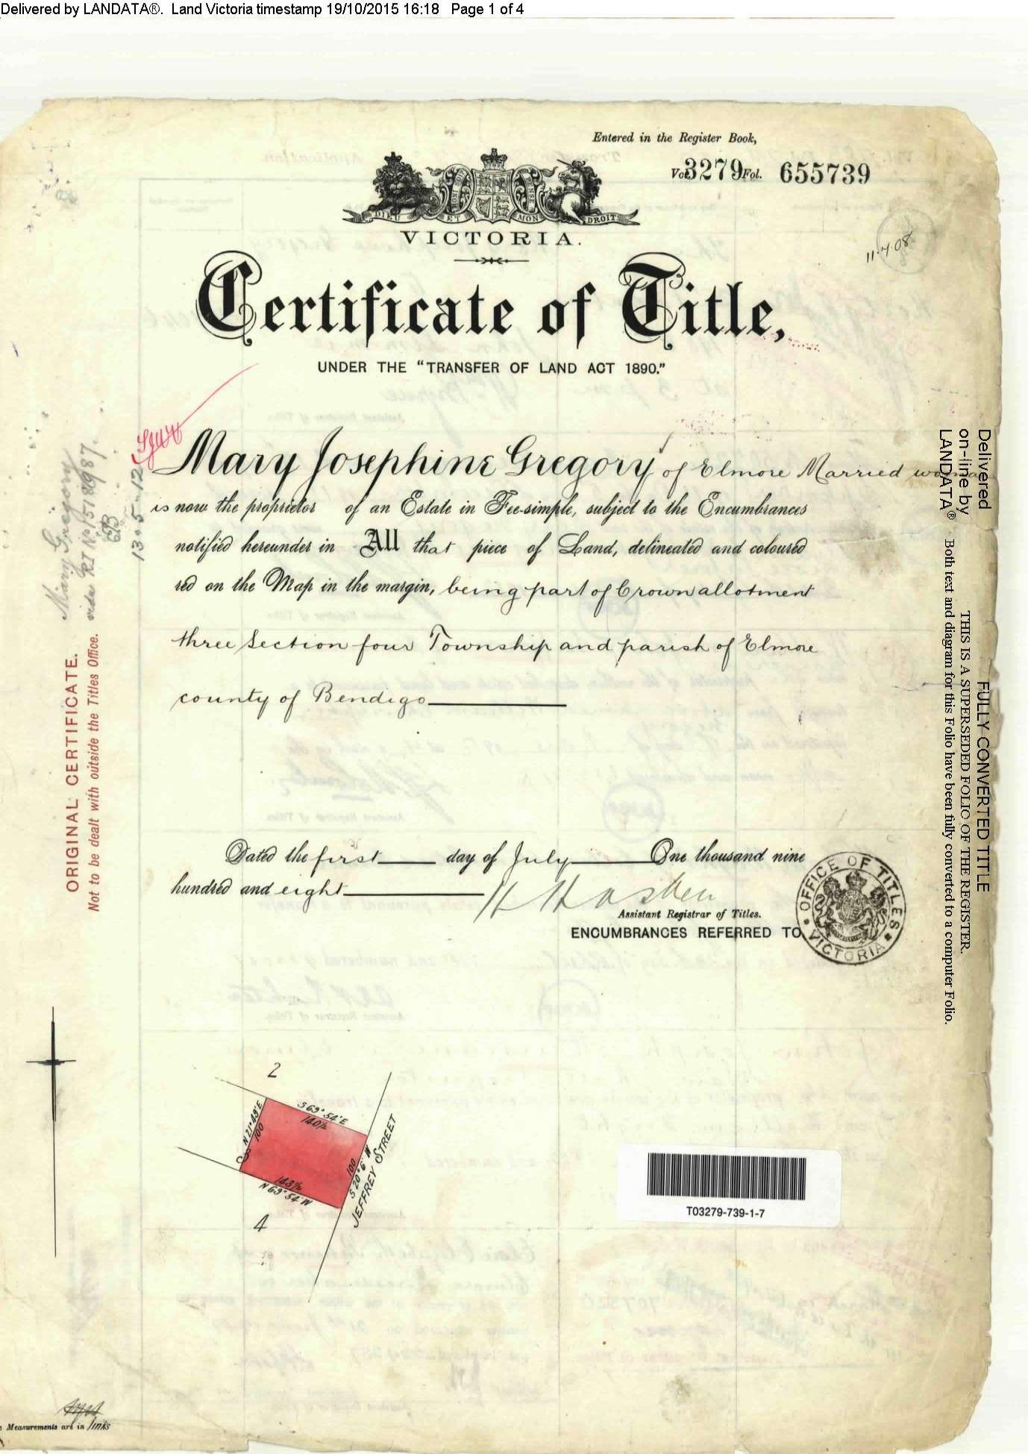
* Information provided by current owner of what was the Riverside Public Hospital, Toni Lackey

